1.Type of data 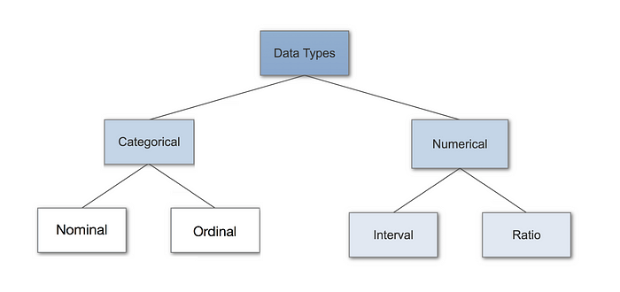Introduction to Data Types
Having a good understanding of the different data types, also called measurement scales, is a crucial prerequisite for doing Exploratory Data Analysis (EDA), since you can use certain statistical measurements only for specific data types.
You also need to know which data type you are dealing with to choose the right visualization method. Think of data types as a way to categorize different types of variables. We will discuss the main types of variables and look at an example for each. We will sometimes refer to them as measurement scales.

Categorical Data
Categorical data represents characteristics. Therefore it can represent things like a person’s gender, language etc. Categorical data can also take on numerical values (Example: 1 for female and 0 for male). Note that those numbers don’t have mathematical meaning.

Nominal Data
Nominal values represent discrete units and are used to label variables, that have no quantitative value. Just think of them as „labels“. Note that nominal data that has no order. Therefore if you would change the order of its values, the meaning would not change.

Numerical Data

1. Discrete Data
We speak of discrete data if its values are distinct and separate. In other words: We speak of discrete data if the data can only take on certain values. This type of data can’t be measured but it can be counted. It basically represents information that can be categorized into a classification. An example is the number of heads in 100 coin flips.

2. Continuous Data
Continuous Data represents measurements and therefore their values can’t be counted but they can be measured. An example would be the height of a person, which you can describe by using intervals on the real number line.
Interval Data
Interval values represent ordered units that have the same difference. Therefore we speak of interval data when we have a variable that contains numeric values that are ordered and where we know the exact differences between the values.
Ratio Data
Ratio values are also ordered units that have the same difference. Ratio values are the same as interval values, with the difference that they do have an absolute zero. Good examples are height, weight, length etc.

- Population vs Sample
In statistics as well as in quantitative methodology, the set of data are collected and selected from a statistical population with the help of some defined procedures. There are two different types of data sets namely, population and sample. So basically when we calculate the mean deviation, variance and standard deviation, it is necessary for us to know if we are referring to the entire population or to only sample data. Suppose the size of the population is denoted by ‘n’ then the sample size of that population is denoted by n -1. Let us take a look of population data sets and sample data sets in detail.
Population
It includes all the elements from the data set and measurable characteristics of the population such as mean and standard deviation are known as a parameter. For example, All people living in India indicates the population of India.
There are different types of population. They are:
- Finite Population
- Infinite Population
- Existent Population
- Hypothetical Population

Sample
It includes one or more observations that are drawn from the population and the measurable characteristic of a sample is a statistic. Sampling is the process of selecting the sample from the population. For example, some people living in India is the sample of the population.
Basically, there are two types of sampling. They are:
- Probability sampling
- Non-probability sampling

Population and Sample Examples
All the people who have the ID proofs is the population and a group of people who only have voter id with them is the sample.
All the students in the class are population whereas the top 10 students in the class are the sample.
All the members of the parliament is population and the female candidates present there is the sample.
Population and Sample Formulas
We will demonstrate here the formulas for mean absolute deviation (MAD), variance and standard deviation based on population and given sample. Suppose n denotes the size of the population and n-1 denotes the sample size, then the formulas for mean absolute deviation, variance and standard deviation are given by;
Difference between Population and Sample

Parameter | Population Parameter | Sample Statistic
Definition | Numerical value that describes a characteristic of a population | Numerical value that describes a characteristic of a sample
Calculation | Calculated using data from the entire population | Calculated using data from a sample of the population
Purpose | Used to describe the entire population | Used to estimate the population parameter
Precision and Accuracy | Usually more precise and accurate than sample statistic | Usually less precise and less accurate than population parameter
Notation | Greek letters (e.g., μ for population mean) | Roman letters (e.g., x̄ for sample mean)
Example | The population mean income of all households in a country | The sample proportion of people who own a car in a randomly selected group of households

3. Inferential statistics vs Descriptive statistics

Statistics is a branch of mathematics dealing with the collection, analysis, interpretation, and presentation of masses of numerical data. It is basically a collection of quantitative data.
Types of Statistics:
- Theoretical Statistics
- Applied Statistics
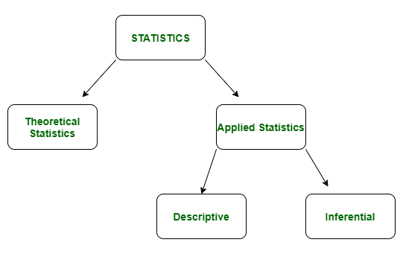
- Descriptive Statistics:
Descriptive statistics is a term given to the analysis of data that helps to describe, show and summarize data in a meaningful way. It is a simple way to describe our data. Descriptive statistics is very important to present our raw data ineffective/meaningful way using numerical calculations or graphs or tables. This type of statistics is applied to already known data.
Types of Descriptive Statistics:
- Measure of Central Tendency
- Measure of Variability
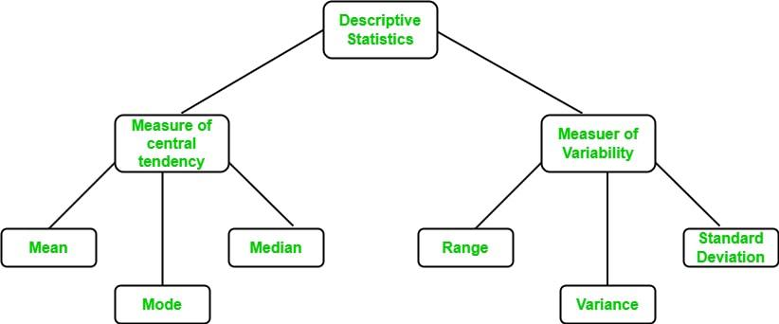

2. Inferential Statistics:
In inferential statistics, predictions are made by taking any group of data in which you are interested. It can be defined as a random sample of data taken from a population to describe and make inferences about the population. Any group of data that includes all the data you are interested in is known as population. It basically allows you to make predictions by taking a small sample instead of working on the whole population.
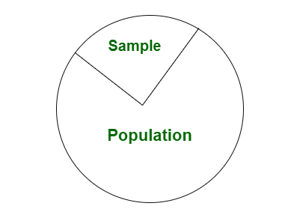

Difference between Descriptive and Inferential statistics:
S.No. | Descriptive Statistics | Inferential Statistics
1. | It gives information about raw data which describes the data in some manner. | It makes inferences about the population using data drawn from the population.
2. | It helps in organizing, analyzing, and to present data in a meaningful manner. | It allows us to compare data, and make hypotheses and predictions.
3. | It is used to describe a situation. | It is used to explain the chance of occurrence of an event.
4. | It explains already known data and is limited to a sample or population having a small size. | It attempts to reach the conclusion about the population.
5. | It can be achieved with the help of charts, graphs, tables, etc. | It can be achieved by probability.

4. Why we analyze only on sample?

Often, a population is too large or extensive in order to measure every member and measuring each member would be expensive and time-consuming. A sample allows for inferences to be made about the population using statistical methods

A sample is an unbiased number of observations taken from a population. In simple terms, a population is the total number of observations (i.e., individuals, animals, items, data, etc.) contained in a given group or context. A sample, in other words, is a portion, part, or fraction of the whole group, and acts as a subset of the population.1 Samples are used in a variety of settings where research is conducted. Scientists, marketers, government agencies, economists, and research groups are among those who use samples for their studies and measurements.
Using whole populations for research comes with challenges. Researchers may have problems gaining ready access to entire populations. And, because of the nature of some studies, researchers may have difficulties getting the results they need in a timely fashion. This is why people samples are used. Using a smaller number of people who represent the entire population can still produce valid results while reducing time and resources.
Samples used by researchers must resemble the broader population in order to make accurate inferences or predictions. All the participants in the sample should share the same characteristics and qualities.1 So, if the study is about male college freshmen, the sample should be a small percentage of males that fit this description. Similarly, if a research group conducts a study on the sleep patterns of single women over 50, the sample should only include women within this demographic.

___________________________________________________________

Frequency table

A frequency table is a way to present data. The data are counted and ordered to summarize larger sets of data.
With a frequency table you can analyze the way the data is distributed across different values.
Frequency Tables
Frequency means the number of times a value appears in the data. A table can quickly show us how many times each value appears.
If the data has many different values, it is easier to use intervals of values to present them in a table.
Here is the age of the 934 Nobel Prize winners up until the year 2020. In the table each row is an age interval of 10 years.
Age Interval | Frequency
10-19 | 1
20-29 | 2
30-39 | 48
40-49 | 158
50-59 | 236
60-69 | 262
70-79 | 174
80-89 | 50
90-99 | 3

We can see that there is only one winner from ages 10 to 19. And that the highest number of winners are in their 60s.

Bar plot and Pie chart
A bar chart depicts numeric values against distinct categories in a two-axis plot. On one axis, the category levels are listed. For each category, one bar is plotted, and its length along the other axis corresponds with the numeric value associated with the category. The example bar plots below show how an app’s user base is divided among different device types. Note that a bar chart can be oriented in two ways, with the bars oriented vertically or horizontally.

Pie chart
A pie chart shows how some total amount is divided among distinct categories as a circle (the namesake pie) divided into radial slices. Each category is associated with a single slice whose size corresponds with the category’s proportion of the total. The figure below plots the same data as above, but using the pie chart form instead.

When pie charts and bar charts can be used
While the example above demonstrates how the same data can be plotted in multiple ways, do not make the mistake of thinking that they are always interchangeable. With a bar chart, there is freedom on the numeric value axis to choose whatever values you’d like. For numeric values that indicate metric totals or data point counts, the sums across groups will tend to be equal to the sum across the data as a whole. In cases like this, a pie chart is just as valid as a bar chart as a visualization choice.
However, if the numeric values indicate some other statistic where the sum across groups does not equal the statistic ignoring groups, that’s when we run into problems. Examples include taking the average of a metric (e.g. average spend by user type) or if we look at proportions that are independent (e.g. proportion of survey respondents who use each of the polled apps). A bar chart is fine for this case, but a pie chart falls short. Since the circular shape implies that slices are parts of a whole, it is too easy for a reader to mistake a sum of slices as a representative of some sort of total.
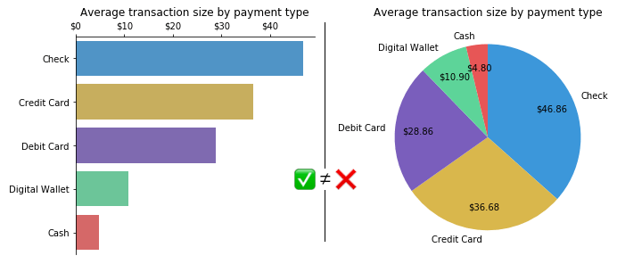

Adding the average transaction sizes will not equal the average of the total. In short, a pie chart can only be used if the sum of the individual parts add up to a meaningful whole, and is built for visualizing how each part contributes to that whole. Meanwhile, a bar chart can be used for a broader range of data types, not just for breaking down a whole into components.
Frequency distribution table
In our day to day life, recording information is very crucial. A piece of information or representation of facts or ideas which can be further processed is known as data. The weather forecast, maintenance of records, dates, time, and everything is related to data collection.
The collection, presentation, analysis, organization and interpretation of observations or data is known as statistics. We can make predictions about the nature of data based on the previous data using statistics. Statistics are helpful when a large amount of data is to be studied and observed.
The collected statistical data can be represented by various methods such as tables, bar graphs, pie charts, histograms, frequency polygons, etc.

What is Frequency Distribution Table in Statistics?

In statistics, a frequency distribution table is a comprehensive way of representing the organisation of raw data of a quantitative variable. This table shows how various values of a variable are distributed and their corresponding frequencies. However, we can make two frequency distribution tables:
(i) Discrete frequency distribution
(ii) Continuous frequency distribution (Grouped frequency distribution)

How to Make a Frequency distribution table?
Frequency distribution tables can be made using tally marks for both discrete and continuous data values. The way of preparing discrete frequency tables and continuous frequency distribution tables are different from each other.
In this section, you will learn how to make a discrete frequency distribution table with the help of examples.
Examples
Suppose the runs scored by the 11 players of the Indian cricket team in a match are given as follows:
25,65,03,12,35,46,67,56,00,31,17
This type of data is in raw form and is known as raw data. The difference between the measure of highest and lowest value in a collection of data is known as the range. When the number of observations increases, this type of representation is quite hectic, and the calculations could be quite complex. As statistics is about the presentation of data in an organized form, the data representation in tabular form is more convenient.
Considering another example: In a quiz, the marks obtained by 20 students out of 30 are given as:
12,15,15,29,30,21,30,30,15,17,19,15,20,20,16,21,23,24,23,21
This data can be represented in tabular form as follows:
Marks obtained in quiz | Number of students(Frequency)
12 | 1
15 | 4
16 | 1
17 | 1
19 | 1
20 | 2
21 | 3
23 | 2
24 | 1
29 | 1
30 | 3
Total | 20
The number of times data occurs in a data set is known as the frequency of data. In the above example, frequency is the number of students who scored various marks as tabulated. This type of tabular data collection is known as an ungrouped frequency table.
What happens if, instead of 20 students, 200 students took the same test. Would it have been easy to represent such data in the format of an ungrouped frequency distribution table? Well, obviously no. To represent a vast amount of information, the data is subdivided into groups of similar sizes known as class or class intervals, and the size of each class is known as class width or class size.

Histogram and Frequency polygon
Histograms look very similar to bar charts but the bars of a histogram are drawn immediately next to each other.
Whereas bar charts represent discrete or categorical data and have gaps between the bars, histograms represent continuous data. There are no gaps between the bars because where one class ends, the next begins immediately.
Procedure for plotting a histogram
- Identify the highest and lowest values to find the range of the data.
- Group the data into classes according to their values such that the class midpoints are convenient numbers. Depending on how much detail is required, choose between 5 and 15 class intervals. Aiming for about 8 classes is a good rule of thumb.
- Tally up the number of values falling into each category. By convention, if a value falls on the boundary between two classes, it is placed in the higher class.
- Construct a histogram by drawing a rectangle for each class with a base width equal to the class interval, and area proportional to the number of observations in that class.
- The x-axis is always labelled with the class midpoints.

Example 1
The weights of the rugby players on the university team are given below. How can this be presented as a histogram?
Weight (Kg) | 67 | 72 | 78 | 81 | 86 | 89 | 90 | 93 | 97 | 98 | 113
Solution
The lowest value is 67 and highest is 113. As there isn't a lot of data, a smaller number of classes would be appropriate. Choosing 5 classes as shown gives class midpoints which are nice whole numbers.

Weight | Class midpoint | Frequency
65-75 | 70 | 2
75-85 | 80 | 2
85-95 | 90 | 4
95-105 | 100 | 2
105-115 | 110 | 1
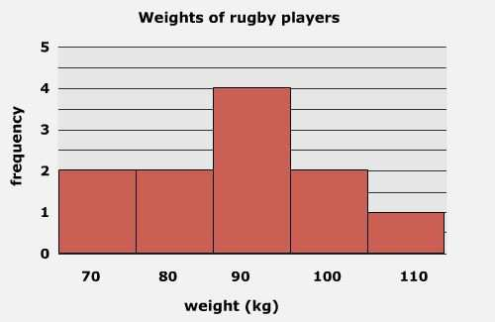
In the example above the class intervals were chosen to be all of the same size. In this case, the height of a rectangle is proportional to the class frequency.The class intervals can be chosen of unequal width. This means that the rectangles drawn would be of non-uniform width, with area proportional to the class frequency.

Frequency Polygons
A frequency polygon is a line graph of class frequency plotted against class mid-point. It can be obtained by connecting the mid-points of the tops of the rectangles in the histogram or drawn as a line graph.
Example 2
How would the weights of the rugby players in example 7 be presented as a frequency polygon?
Solution
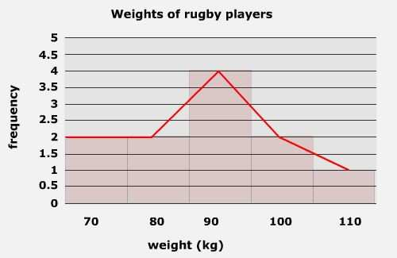

Method to create class interval and width of the interval

Class width refers to the difference between the upper and lower boundaries of any class (category). Depending on the author, it’s also sometimes used more specifically to mean:
- The difference between the upper limits of two consecutive (neighboring) classes, or
- The difference between the lower limits of two consecutive classes.
Note that these are different than the difference between the upper and lower limits of a class.

Calculating Class Width in a Frequency Distribution Table

In a frequency distribution table, classes must all be the same width. This makes it relatively easy to calculate the class width, as you’re only dealing with a single width (as opposed to varying ones). To find the width:
- Calculate the range of the entire data set by subtracting the lowest point from the highest,
- Divide it by the number of classes.
- Round this number up (usually, to the nearest whole number).

Example of Calculating Class Width
Suppose you are analyzing data from a final exam given at the end of a statistics course. The number of classes you divide them into is somewhat arbitrary, but there are a few things to keep in mind:

- Make few enough categories so that you have more than one item in each category.
- Choose a number that is easy to manipulate; usually, something between five and twenty is a good idea. For example, if you are analyzing a relatively small class of 25 students, you might decide to create a frequency table with five classes.
Example: Find a reasonable class with for the following set of student scores:
52, 82, 86, 83, 56, 98, 71, 91, 75, 88, 69, 78, 64, 74, 81, 83, 77, 90, 85, 64, 79, 71, 64, and 83.
- Find the range by subtracting the lowest point from the highest: the difference between the highest and lowest score: 98 – 52 = 46.
- Divide it by the number of classes: 46/5, = 9.2.
- Round this number up: 9.2≅ 10.

Class Interval
Class interval is a term that is used to denote the numerical width of a class in a frequency distribution. In a grouped frequency distribution, data is arranged in the form of a class. The difference between the upper-class limit and the lower limit gives the class interval.
In statistics, there are two types of class intervals, namely exclusive and inclusive class intervals. Based on these, a frequency distribution table can be constructed. In this article, we will learn more about a class interval, its types, formula, graph, and see some examples.

What is Class Interval in Statistics?
A class interval is used in a frequency distribution table to organize the data obtained from an experiment systematically. The classes in a frequency distribution are usually mutually exclusive. A histogram can be easily constructed by using class intervals.

Definition of Class Interval
A class interval can be defined as the difference between the upper and lower class limit of a frequency distribution table. In other words, it is the width of each class. A grouped frequency distribution can be sorted either on the basis of exclusive or inclusive class intervals.

Class Interval Example
Suppose there is a class given by 11 - 21. 11 will be known as the lower class limit while 21 is the upper limit. The class interval is given by 21 - 11 = 10.

Class Interval Formula
To determine the class interval, the lower limit of the class is subtracted from the upper limit. The class interval formula is given as follows:
Class interval = Upper Limit - Lower Limit.

Inclusive Class Interval
An inclusive class interval is created using the inclusive method of sorting data into a frequency distribution table. In such a method, the lower limit of a class does not get repeated in the upper limit of the preceding class. When a frequency distribution is analyzed the inclusive class interval has to be converted to an exclusive class interval. This can be done by subtracting 0.5 from the lower class limit and adding 0.5 to the upper class limit. An example of an inclusive class interval is given below:
Class | Adjusted Class | Frequency
10 - 19 | 9.5 - 19.5 | 2
20 - 29 | 19.5 - 29.5 | 5
30 - 39 | 29.5 - 39.5 | 1

Exclusive Class Interval
In an exclusive class interval, the upper limit of one class is the same as the lower limit of the succeeding class. This method of sorting data ensures continuity between two consecutive classes. The value of the mean, median, and mode will be the same irrespective of whether the frequency distribution table has an inclusive or exclusive class interval. Given below is an example of an exclusive class interval.
Class | Frequency
10 - 20 | 2
20 - 30 | 5
30 - 40 | 1

Class Interval Histogram
A histogram is used for visually representing a continuous frequency distribution table. An exclusive class interval can be directly represented on the histogram. However, an inclusive class interval needs to be first converted to an exclusive class interval before graphically representing it. The x-axis represents the class interval and the y axis represents the corresponding frequency.
Suppose a frequency distribution table is given as follows:
Class | Frequency
0 - 10 | 8
10 - 20 | 12
20 - 30 | 16
30 - 40 | 14
40 - 50 | 10
50 - 60 | 5
The class interval histogram is given below:
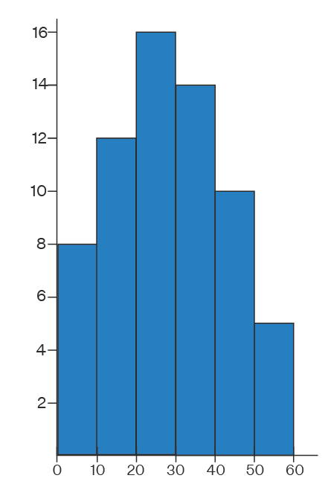

Introduction to Mean, Median and Mode: Often in statistics, we tend to represent a set of data by a representative value which would approximately define the entire collection. This representative value is called the measure of central tendency, and the name suggests that it is a value around which the data is centred. These central tendencies are mean, median and mode.
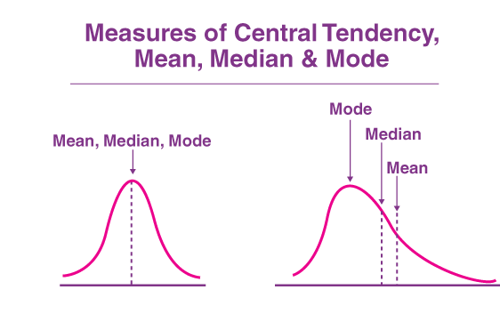
We are all interested in cricket but have you ever wondered during the match why the run rate of the particular over is projected and what does the run rate mean? Or, when you get your examination result card, you mention the aggregate percentage. Again what is the meaning of aggregate? All these quantities in real life make it easy to represent a collection of data in terms of a single value. It is called Statistics.
Statistics deals with the collection of data and information for a particular purpose. The tabulation of each run for each ball in cricket gives the statistics of the game. The representation of any such data collection can be done in multiple ways, like through tables, graphs, pie-charts, bar graphs, pictorial representation etc.
Now consider a 50 over ODI match going between India and Australia. India scored 370 runs by the end of the first innings. How do you decide whether India put a good score or not? It’s pretty simple, right; you find the overall run rate, which is good for such a score. Thus, here comes the concept of mean, median and mode in the picture. Let us learn in detail each of the central tendencies.

----------------------------------------------------------------------------------------

Central tendency
- Mean
- Median
- Mode

Measures of central tendency
The measures of central tendencies are given by various parameters but the most commonly used ones are mean, median and mode. These parameters are discussed below.

What is Mean?
Mean is the most commonly used measure of central tendency. It actually represents the average of the given collection of data. It is applicable for both continuous and discrete data.
It is equal to the sum of all the values in the collection of data divided by the total number of values.

How to Find the Mean
Finding the mean is very simple. Just add all the values and divide by the number of observations. The mean formula is below:
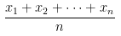
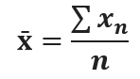

Where:
- x̄ is the sample average of variable x.
- ∑xn= sum of n values.
- n = number of values in the sample.

What is Median?
Generally median represents the mid-value of the given set of data when arranged in a particular order.
Median: Given that the data collection is arranged in ascending or descending order, the following method is applied:
- If number of values or observations in the given data is odd, then the median is given by [(n+1)/2]th observation.
- If in the given data set, the number of values or observations is even, then the median is given by the average of (n/2)th and [(n/2) +1]th observation.

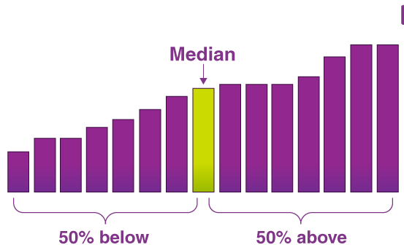

How to Calculate the Median?
To find the median, place all the numbers in ascending order and find the middle.
Example 1:
Find the Median of 14, 63 and 55
solution:
Put them in ascending order: 14, 55, 63
The middle number is 55, so the median is 55.
Example 2:
Find the median of the following:
4, 17, 77, 25, 22, 23, 92, 82, 40, 24, 14, 12, 67, 23, 29
Solution:
When we put those numbers in the order, we have:
4, 12, 14, 17, 22, 23, 23, 24, 25, 29, 40, 67, 77, 82, 92,
There are fifteen numbers. Our middle is the eighth number:
The median value of this set of numbers is 24.

What is Mode?
The most frequent number—that is, the number that occurs the highest number of times.
Example: The mode of {4{4left brace, 4, 222, 444, 333, 222, 2}2}2, right brace is 222 because it occurs three times, which is more than any other number.

Finding the mode
The mode is the most commonly occurring data point in a dataset. The mode is useful when there are a lot of repeated values in a dataset. There can be no mode, one mode, or multiple modes in a dataset.

Example 1
Ms. Norris asked students in her class how many siblings they each had.
Find the mode of the data:
000, 000, 111, 111, 111, 111, 111, 111, 222, 222, 222, 333, 555
Look for the value that occurs the most:
000, 000, 111, 111, 111, 111, 111, 111, 222, 222, 222, 333, 555
The mode is 111 sibling.

Example:
To find out the median let us first arrange the given data in ascending order
Name | Harbhajan | Dhoni | Virat | Yuvraj | Sehwag | Rohit | Sachin
Runs | 1 | 6 | 40 | 52 | 52 | 70 | 80
As the number of items in the data is odd. Hence, the median is [(n+1)/2]th observation.
⇒ Median = [(7+1)/2]th observation = 52
iii) Mode is the most frequent data, which is 52.

Relation of Mean Median Mode
The relation between mean, median and mode that means the three measures of central tendency for moderately skewed distribution is given the formula:
Mode = 3 Median – 2 Mean
This relation is also called an empirical relationship. This is used to find one of the measures when the other two measures are known to us for certain data. This relationship is rewritten in different forms by interchanging the LHS and RHS.

Range
In statistics, the range is the difference between the highest and lowest data value in the set. The formula is:
Range – Highest value – Lowest value

Solved Problem
Question: Find the mean, median, mode and range for the given data:
90, 94, 53, 68, 79, 94, 53, 65, 87, 90, 70, 69, 65, 89, 85, 53, 47, 61, 27, 80
Solution:
Given,
90, 94, 53, 68, 79, 94, 53, 65, 87, 90, 70, 69, 65, 89, 85, 53, 47, 61, 27, 80
Number of observations = 20
Mean = (Sum of observations)/ Number of observations
= (90 + 94 + 53 + 68 + 79 + 94 + 53 + 65 + 87 + 90 + 70 + 69 + 65 + 89 + 85 + 53 + 47 + 61 + 27 + 80)/20
= 1419/20
= 70.95
Therefore, mean is 70.95.
Median:
The ascending order of given observations is:
27, 47, 53, 53, 53, 61, 65, 65, 68, 69, 70, 79, 80, 85, 87, 89, 90, 90, 94,94
Here, n = 20
Median = 1/2 [(n/2) + (n/2 + 1)]th observation
= 1/2 [10 + 11]th observation
= 1/2 (69 + 70)
= 139/2
= 69.5
Thus, the median is 69.5.
Mode:
The most frequently occurred value in the given data is 53.
Therefore, mode = 53
Range = Highest value – Lowest value
= 94 – 27
= 67

Data dispersion
- Range
- Mean deviation
- Absolute mean deviation
- Variance
- Standard deviation

What is Dispersion in Statistics
Dispersion in statistics is a way of describing how to spread out a set of data is. Dispersion is the state of data getting dispersed, stretched, or spread out in different categories. It involves finding the size of distribution values that are expected from the set of data for the specific variable. The meaning of dispersion in statistics is “numeric data that is likely to vary at any instance of average value assumption”.
Dispersion of data in Statistics helps one to easily understand the dataset by classifying them into their own specific dispersion criteria like variance, standard deviation and ranging.
Dispersion is a set of measures that helps one to determine the quality of data in an objectively quantifiable manner. Most often data science courses start with the basics of statistics and dispersion is one such concept that you cannot afford to skip.

Measures of Dispersion
The measures of dispersion contain almost the same unit as the quantity being measured. There are many Measures of Dispersion found that help us to get more insights into the data:
- Range
- Variance
- Standard Deviation
- Skewness
- IQR


Types of Measures of Dispersion
The Measure of Dispersion in Statistics is divided into two main categories and offer ways of measuring the diverse nature of data. It is mainly used in biological statistics. We can easily classify them by checking whether they contain units or not.
So as per the above, we can divide the data into two categories which are:
- Absolute Measures of Dispersion
- Relative Measures of Dispersion
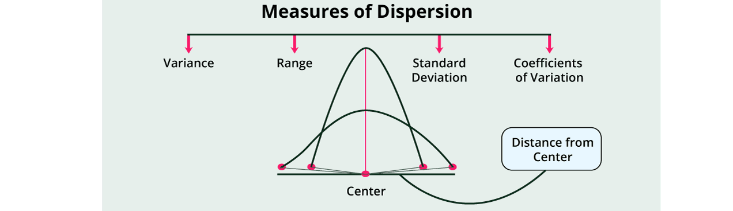

Absolute Measures of Dispersion
Absolute Measures of Dispersion is one with units; it has the same unit as the initial dataset. Absolute Measure of Dispersion is expressed in terms of the average of the dispersion quantities like Standard or Mean deviation. The Absolute Measure of Dispersion can be expressed in units such as Rupees, Centimetre, Marks, kilograms, and other quantities that are measured depending on the situation.

Types of Absolute Measure of Dispersion in Statistics:
Range: Range is the measure of the difference between the largest and smallest value of the data variability. The range is the simplest form of Measures of Dispersion.
- Example: 1,2,3,4,5,6,7
- Range = Highest value – Lowest value
- = ( 7 – 1 ) = 6

Mean (μ): Mean is calculated as the average of the numbers. To calculate the Mean, add all the outcomes and then divide it with the total number of terms.
Example: 1,2,3,4,5,6,7,8
Mean = (sum of all the terms / total number of terms)
= (1 + 2 + 3 + 4 + 5 + 6 + 7 + 8) / 8
= 36 / 8
= 4.5
Variance (σ2): In simple terms, the variance can be calculated by obtaining the sum of the squared distance of each term in the distribution from the Mean, and then dividing this by the total number of the terms in the distribution.
It basically shows how far a number, for example, a student’s mark in an exam, is from the Mean of the entire class.
Formula:
(σ2) = ∑ ( X − μ)2 / N
Standard Deviation: Standard Deviation can be represented as the square root of Variance. To find the standard deviation of any data, you need to find the variance first. Standard Deviation is considered the best measure of dispersion.
Formula:
Standard Deviation = √σ
Quartile: Quartiles divide the list of numbers or data into quarters. Quartile Deviation: Quartile Deviation is the measure of the difference between the upper and lower quartile. This measure of deviation is also known as the interquartile range.
Formula:
Interquartile Range: Q3 – Q1.
Mean deviation: Mean Deviation is also known as an average deviation; it can be computed using the Mean or Median of the data. Mean deviation is represented as the arithmetic deviation of a different item that follows the central tendency.

Formula:
As mentioned, the Mean Deviation can be calculated using Mean and Median.
- Mean Deviation using Mean: ∑ | X – M | / N
- Mean Deviation using Median: ∑ | X – X1 | / N

Relative Measures of Dispersion
Relative Measure of Dispersion in Statistics are the values without units. A relative measure of dispersion is used to compare the distribution of two or more datasets.
The definition of the Relative Measure of Dispersion is the same as the Absolute Measure of Dispersion; the only difference is the measuring quantity.
Types of Relative Measure of Dispersion: Relative Measure of Dispersion is the calculation of the co-efficient of Dispersion, where 2 series are compared, which differ widely in their average.
The main use of the co-efficient of Dispersion is when 2 series with different measurement units are compared.

Why dispersion is important in a statistic?
The knowledge of dispersion is vital in the understanding of statistics. It helps to understand concepts like the diversification of the data, how the data is spread, how it is maintained, and maintaining the data over the central value or central tendency.
Moreover, dispersion in statistics provides us with a way to get better insights into data distribution.
For example,
3 distinct samples can have the same Mean, Median, or Range but completely different levels of variability.

How to Calculate Dispersion
Dispersion can be easily calculated using various dispersion measures, which are already mentioned in the types of Measures of Dispersion described above. Before measuring the data, it is important to understand the diversion of the terms and variations.
One can use the following method to calculate the dispersion:
- Mean
- Standard deviation
- Variance
- Quartile deviation
For example, let us consider two datasets:
- Data A:97,98,99,100,101,102,103
- Data B: 70,80,90,100,110,120,130
On calculating the mean and median of the two datasets, both have the same value, which is 100. However, the rest of the dispersion measures are totally different as measured by the above methods.
The range of B is 10 times higher, for instance.

How to represent Dispersion in Statistics
Dispersion in Statistics can be represented in the form of graphs and pie-charts. Some of the different ways used include:
- Dot Plots
- Box Plots
- Stems
- Leaf Plots

Example: What is the variance of the values 3,8,6,10,12,9,11,10,12,7?
Variation of the values can be calculated using the following formula:
- (σ2) = ∑ ( X − μ)2 / N
- (σ2) = 7.36

What is an example of dispersion?
One of the examples of dispersion outside the world of statistics is the rainbow- where white light is split into 7 different colours separated via wavelengths.
Some statistical ways of measuring it are-
- Standard deviation
- Range
- Mean absolute difference
- Median absolute deviation
- Interquartile change
- Average deviation

Normal distribution and Its formulae

In probability theory and statistics, the Normal Distribution, also called the Gaussian Distribution, is the most significant continuous probability distribution. Sometimes it is also called a bell curve. A large number of random variables are either nearly or exactly represented by the normal distribution, in every physical science and economics. Furthermore, it can be used to approximate other probability distributions, therefore supporting the usage of the word ‘normal ‘as in about the one, mostly used.

Normal Distribution Definition
The Normal Distribution is defined by the probability density function for a continuous random variable in a system. Let us say, f(x) is the probability density function and X is the random variable. Hence, it defines a function which is integrated between the range or interval (x to x + dx), giving the probability of random variable X, by considering the values between x and x+dx.
f(x) ≥ 0 ∀ x ϵ (−∞,+∞)
And -∞∫+∞ f(x) = 1

Normal Distribution Formula
The probability density function of normal or gaussian distribution is given by;
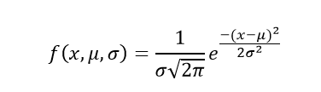
Where,
- x is the variable
- μ is the mean
- σ is the standard deviation

Normal Distribution Curve
The random variables following the normal distribution are those whose values can find any unknown value in a given range. For example, finding the height of the students in the school. Here, the distribution can consider any value, but it will be bounded in the range say, 0 to 6ft. This limitation is forced physically in our query.
Whereas, the normal distribution doesn’t even bother about the range. The range can also extend to –∞ to + ∞ and still we can find a smooth curve. These random variables are called Continuous Variables, and the Normal Distribution then provides here probability of the value lying in a particular range for a given experiment. Also, use the normal distribution calculator to find the probability density function by just providing the mean and standard deviation value.

Normal Distribution Standard Deviation
Generally, the normal distribution has any positive standard deviation. We know that the mean helps to determine the line of symmetry of a graph, whereas the standard deviation helps to know how far the data are spread out. If the standard deviation is smaller, the data are somewhat close to each other and the graph becomes narrower. If the standard deviation is larger, the data are dispersed more, and the graph becomes wider. The standard deviations are used to subdivide the area under the normal curve. Each subdivided section defines the percentage of data, which falls into the specific region of a graph.
Using 1 standard deviation, the Empirical Rule states that,
- Approximately 68% of the data falls within one standard deviation of the mean. (i.e., Between Mean- one Standard Deviation and Mean + one standard deviation)
- Approximately 95% of the data falls within two standard deviations of the mean. (i.e., Between Mean- two Standard Deviation and Mean + two standard deviations)
- Approximately 99.7% of the data fall within three standard deviations of the mean. (i.e., Between Mean- three Standard Deviation and Mean + three standard deviations)

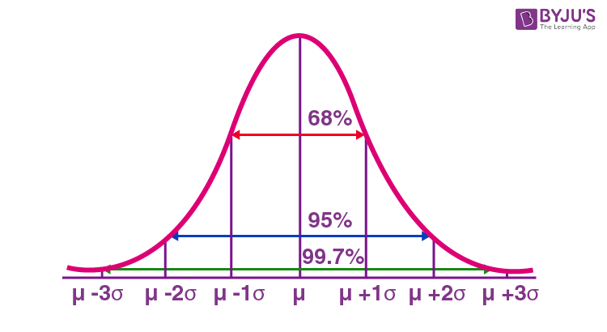

Negative skewed vs Positive skewed vs Normal

Skewness essentially is a commonly used measure in descriptive statistics that characterizes the asymmetry of a data distribution, while kurtosis determines the heaviness of the distribution tails.”

Skewness is a statistical measure that assesses the asymmetry of a probability distribution. It quantifies the extent to which the data is skewed or shifted to one side.
Positive skewness indicates a longer tail on the right side of the distribution, while negative skewness indicates a longer tail on the left side. Skewness helps in understanding the shape and outliers in a dataset.
If the values of a specific independent variable (feature) are skewed, depending on the model, skewness may violate model assumptions or may reduce the interpretation of feature importance.
In statistics, skewness is a degree of asymmetry observed in a probability distribution that deviates from the symmetrical normal distribution (bell curve) in a given set of data.
A skewed data set, typical values fall between the first quartile (Q1) and the third quartile (Q3).
The normal distribution helps to know a skewness. When we talk about normal distribution, data symmetrically distributed. The symmetrical distribution has zero skewness as all measures of a central tendency lies in the middle.
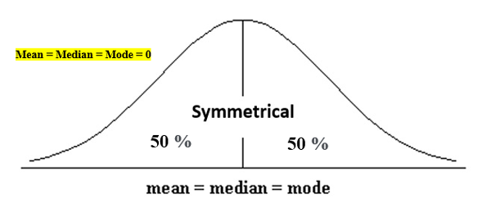

Types of Skewness

Positive Skewed or Right-Skewed (Positive Skewness)
In statistics, a positively skewed or right-skewed distribution has a long right tail. It is a sort of distribution where the measures are dispersing, unlike symmetrically distributed data where all measures of the central tendency (mean, median, and mode) equal each other. This makes Positively Skewed Distribution a type of distribution where the mean, median, and mode of the distribution are positive rather than negative or zero.

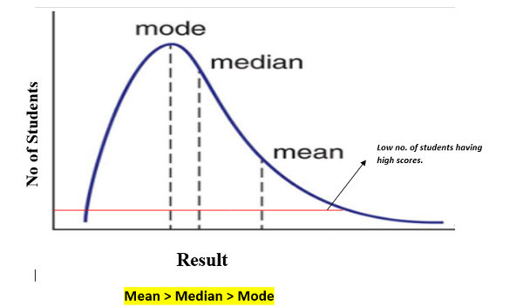

In positively skewed, the mean of the data is greater than the median (a large number of data-pushed on the right-hand side). In other words, the results are bent towards the lower side. The mean will be more than the median as the median is the middle value and mode is always the most frequent value.
Extreme positive skewness is not desirable for a distribution, as a high level of skewness can cause misleading results. The data transformation tools are helping to make the skewed data closer to a normal distribution. For positively skewed distributions, the famous transformation is the log transformation. The log transformation proposes the calculations of the natural logarithm for each value in the dataset.

Negative Skewed or Left-Skewed (Negative Skewness)
A negatively skewed or left-skewed distribution has a long left tail; it is the complete opposite of a positively skewed distribution. In statistics, negatively skewed distribution refers to the distribution model where more values are plots on the right side of the graph, and the tail of the distribution is spreading on the left side.
In negatively skewed, the mean of the data is less than the median (a large number of data-pushed on the left-hand side). Negatively Skewed Distribution is a type of distribution where the mean, median, and mode of the distribution are negative rather than positive or zero.
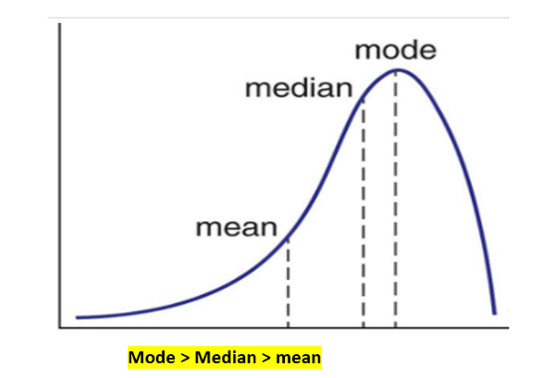

What is the Empirical Rule?
The empirical rule in statistics, also known as the 68 95 99 rule, states that for normal distributions, 68% of observed data points will lie inside one standard deviation of the mean, 95% will fall within two standard deviations, and 99.7% will occur within three standard deviations.
Thanks to the empirical rule, the mean and standard deviation become extra valuable when you reasonably expect that your data approximate a normal distribution. Simply knowing these two statistics allows you to calculate probabilities and percentages for various outcomes.
The name of the empirical rule comes from empirical research, which uses observations and measurements of real-world outcomes rather than theory. In other words, empirical means it is grounded in practical reality. The empirical rule takes these recorded outcomes and lets you use them to make forecasts and calculate probabilities.
Additionally, statisticians also refer to the empirical rule as the three-sigma rule because nearly all observations occur within three standard deviations. This rule sets a statistical control chart’s upper and lower limits at +/- three standard deviations. In general, this limit serves as a valuable way to identify outliers because 99.7% of all values should fall within it.
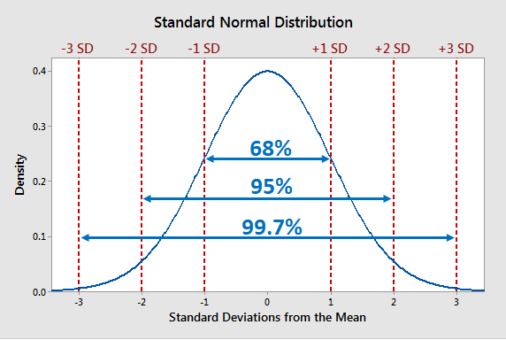

Chebyshev’s Theorem in Statistics
Chebyshev’s Theorem estimates the minimum proportion of observations that fall within a specified number of standard deviations from the mean. This theorem applies to a broad range of probability distributions. Chebyshev’s Theorem is also known as Chebyshev’s Inequality.
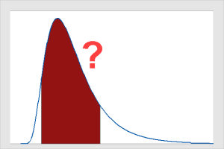
If you have a mean and standard deviation, you might need to know the proportion of values that lie within, say, plus and minus two standard deviations of the mean. If your data follow the normal distribution, that’s easy using the Empirical Rule! However, what if you don’t know the

Chebyshev’s Theorem helps you determine where most of your data fall within a distribution of values. This theorem provides helpful results when you have only the mean and standard deviation. You do not need to know the distribution your data follow.
There are two forms of the equation. One determines how close to the mean the data lie and the other calculates how far away from the mean they fall:
Maximum proportion of observations that are more than k standard deviations from the mean
Minimum proportion of observations that are within k standard deviations of the mean | 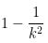
Where k equals the number of standard deviations in which you are interested. K must be greater than 1.
As you can see, it’s a fairly straightforward equation.
For more information about the mean and standard deviation, read my posts about Measures of Central Tendency and Measures of Variability.

Using Chebyshev’s Theorem
By entering values for k into the equation, I’ve created the table below that displays proportions for various standard deviations.
Standard Deviations | Minimum % within | Max % outside
 | 0.50 | 0.50
1.5 | 0.56 | 0.44
2 | 0.75 | 0.25
3 | 0.89 | 0.11
4 | 0.94 | 0.06
5 | 0.96 | 0.04

0 seconds of 0 secondse 0
On the other hand, quantile refers to the division of a population into equal parts based on a certain criteria. For example, if a population of test scores is divided into four equal parts based on the scores, each part would represent a quartile. Quantiles are often used in data analysis to identify patterns or trends within a population.
While percentile and quantile are related concepts, they are not interchangeable. Understanding the difference between these two terms can help you better interpret data and make more informed decisions based on that data. In the following sections, we will explore the applications of percentile and quantile in more detail.

Define Percentile
A percentile is a statistical measure that indicates the percentage of observations that fall below a particular value in a dataset. In other words, it divides the data into 100 equal parts and ranks each observation according to its position in the distribution. For example, if a student scores in the 90th percentile on a standardized test, it means that they scored higher than 90% of the other test-takers.

Quantile
A quantile is a statistical measure that divides a dataset into equal parts based on the percentage of observations below a particular value. Unlike percentiles, which divide the data into 100 equal parts, quantiles can divide the data into any number of equal parts. For example, the median is a type of quantile that divides the data into two equal parts, with 50% of the observations below and 50% above.

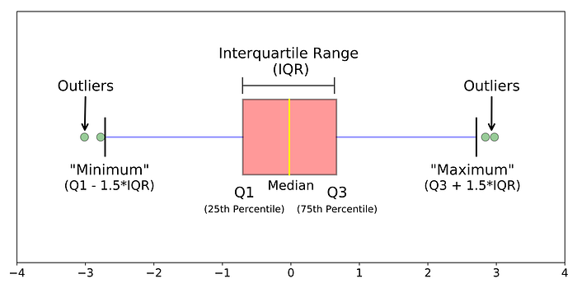
In descriptive statistics, a box plot or boxplot is a method for graphically depicting groups of numerical data through their quartiles. Box plots may also have lines extending vertically from the boxes (whiskers) indicating variability outside the upper and lower quartiles, hence the terms box-and-whisker plot and box-and-whisker diagram.

Boxplots are a standardized way of displaying the distribution of data based on a five number summary (“minimum”, first quartile (Q1), median, third quartile (Q3), and “maximum”).
This type of plot is used to easily detect outliers. It can also tell us if your data is symmetrical, how tightly your data is grouped, and if and how your data is skewed.
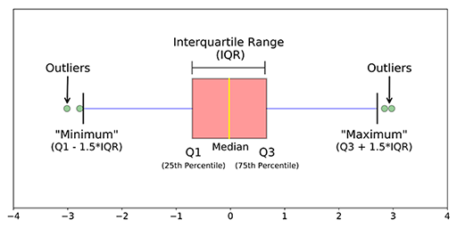
- median (Q2/50th Percentile): the middle value of the dataset.
- first quartile (Q1/25th Percentile): the middle number between the smallest number (not the “minimum”) and the median of the dataset.
- third quartile (Q3/75th Percentile): the middle value between the median and the highest value (not the “maximum”) of the dataset.
- InterQuartile Range (IQR): 25th to the 75th percentile. IQR tells how spread the middle values are.
- “maximum”: Q3 + 1.5*IQR
- “minimum”: Q1 -1.5*IQR
- Outliers: (shown as green circles) In statistics, an outlier is an observation point that is distant from other observations.
Not every outlier is a wrong value!

What Is Covariance?
Covariance measures the directional relationship between the returns on two assets. A positive covariance means asset returns move together, while a negative covariance means they move inversely.
Covariance is calculated by analyzing at-return surprises (standard deviations from the expected return) or multiplying the correlation between the two random variables by the standard deviation of each variable.
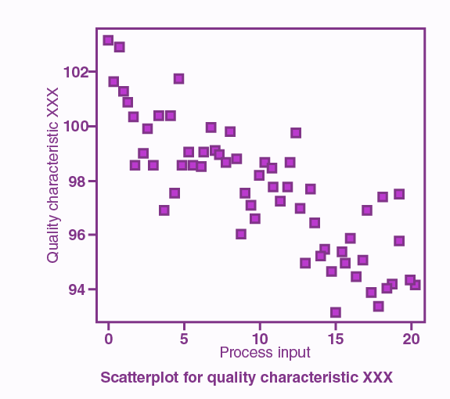
The line drawn in a scatter plot, which is near to almost all the points in the plot is known as “line of best fit” or “trend line“. See the graph below for an example.
